Instructions:
- https://www.pearsonmylabandmastering.com/northamerica/
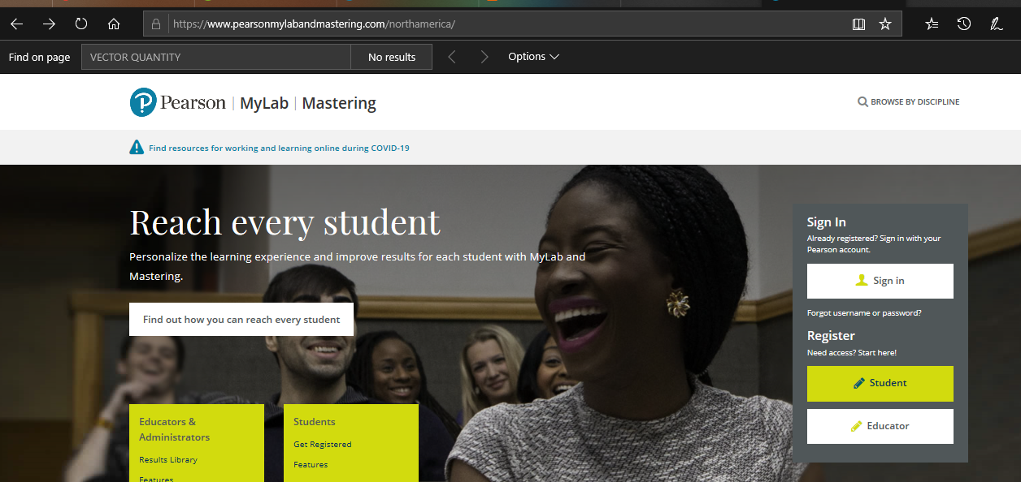
- Right hand click on sign in
Log in : nt713851@gmail.com
Password: Irving123
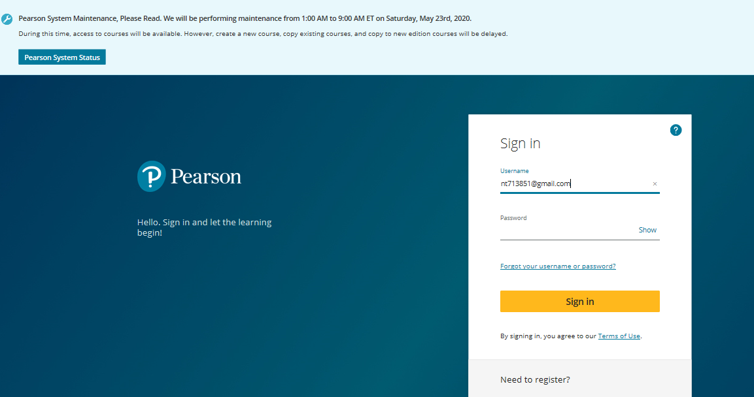
3. After you press enter you will then click on Physics 1
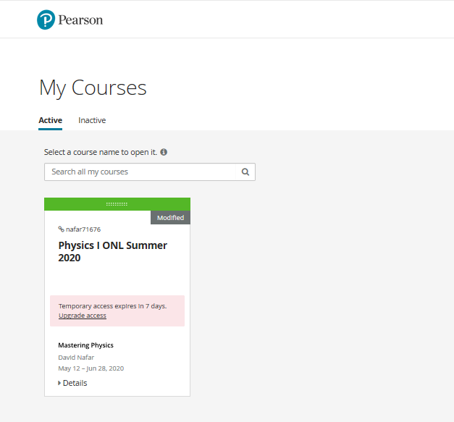
- You will click on upcoming date on calendar and the homework assignments will come up.
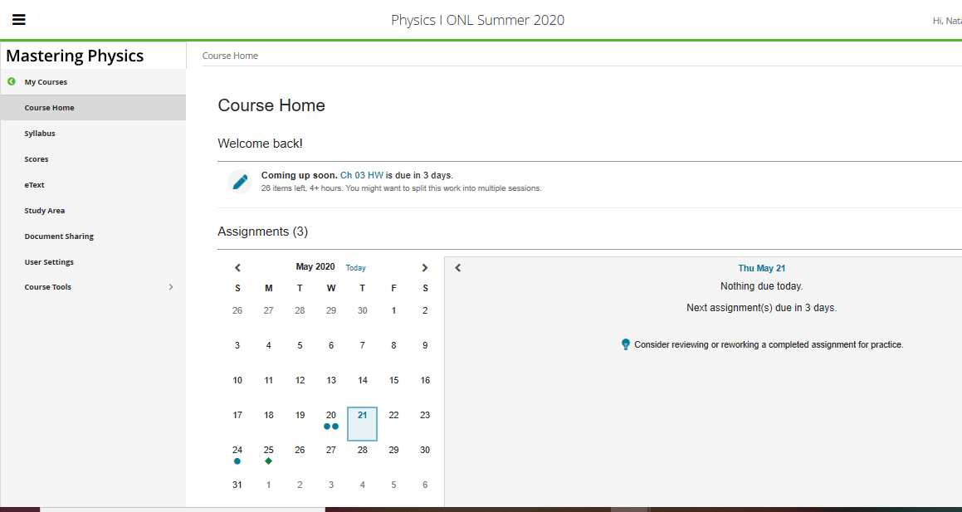
- There are 2 assignments that are due by 5/24th. Assignments are posted every week. And due on Sunday.
